**Project Report**

**Overview:**

Big Mountain resort added a new chair lift to in their park and was concerned about the additional operational cost of $1,540,000 it brings along. Stakeholders are trying to find ways in order to recoup the additional cost by finding an executable, non-invasive solution that provides additional revenue without compromising the park’s overall margin of 9.2%. In order to come up with a solution, the method we use is to create a model for the weekend ticket prices through regression and see if based on Big Mountain’s characteristics, an increase in weekend ticket prices can be a justifiable solution. The data we use and collect are characteristic and operational data from ski resorts across the United States, which includes transport lifts, ticket prices, as well as their topography among other things. The deliverable of this research is the resulting expected price that our model develop and see how it compares with the current price.

**Data pre-processing of note:**

The data we use consists of 331 different ski resorts across the United States, each have 25 different variables. The variables are different common characteristics that appear in each of the resorts, which includes local logistics (count of different kind of trams, etc.), topography(elevation level, total area), and sales(ticket prices). A dummy variable was created for the states, but the resulting model from using state data does was not satisfying. Some of the ski resorts that characteristics are similar, or have high collinearity, were dropped, resulting only 167 ski resorts used for training.

**Model Description**

The final data that we use was as stated above, from 167 ski resorts consists of 23 different variables by excluding Name, State, and weekend ticket prices. The method we use is linear regression, and the result performance is as follow:

R2 = .556 ~ 56%

MAE = 6.85

Current weekend price for Big Mountain = $49

Suggested weekend price for Big Mountain from the model = $58

Delta Price = ~ 18%

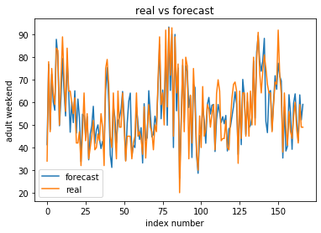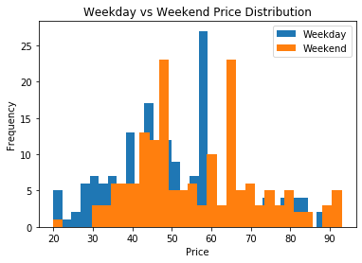

**Conclusion**

An increase in weekend price is a suitable solution for the current problem, and increasing ticket price will not hurt the margin, but instead increase it to a healthier state. Most importantly, this solution can be very easily and realistically implemented.